***A1. Explain binary system and Logic gates applications:***

To begin with there are few types of logic gates, such as:

1. AND gate;

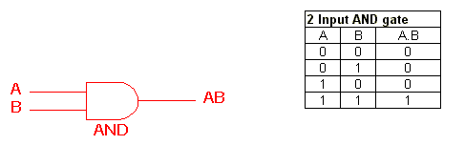

1. OR gate;

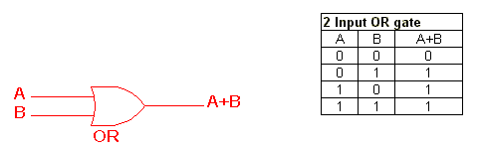

1. NOT gate;

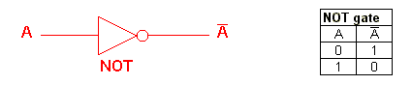

1. NAND gate;

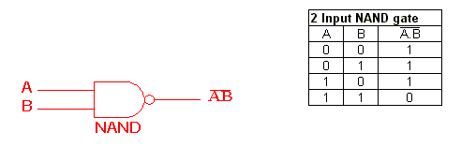

1. NOR gate;

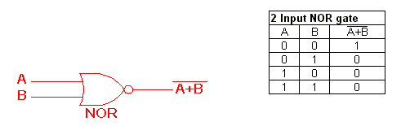

1. EXOR gate;

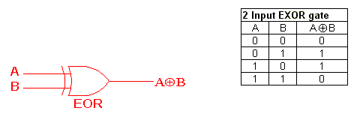

1. EXNOR gate;

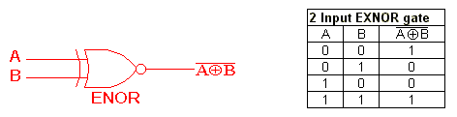

* On the previous pictures, I’ve showed you symbol and truth table for each of the Logic gates. A and B are inputs, third column – is an output. Understanding the functionality of each of them is crucial, because if you are using Ladder diagram in programing of PLC controller (Ladder diagram (LD) - is the most common programing technique for PLC controllers, apart of that you could also use: Sequential Function Charts (SFC), Function Block Diagram (FBD), Structured Text (ST), or Instruction List (IL).

The most valuable difference between all of them is a possibility of using some commands or functions. For example sometimes you have to use a command which is available only in “Ladder diagram” and unavailable in the rest of techniques, and vise versa.)

If we know the functionality of Logic gates – we could easily create a program for our PLC. We could use Binary table (truth table) or Diagram, or Equation. The main rules are : OR – our inputs are set in parallel, AND – they are set in series, than you have to take a look on the output of your truth table and check where is the output = 1, than check the binary code in front of it, and than make a program. For example if you have 0 0 1 = 1, you will need to make two normally closed and one normally open switches. You are interested only in lines where output is equal 1.

For example :

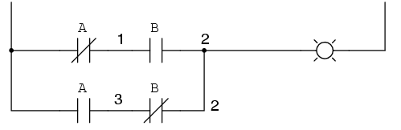

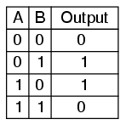

***Question 1:***

***A2. Explain the principles and concepts of control systems.***

***A4. Describe the general architecture of microprocessor-based systems and PLC.***

A programmable logic controller (PLC) - is a special type of computer that is commonly used in commercial and industrial settings. PLC is designed to run automated systems such as: robotics or other machines and use inputs and outputs to read and send data. Unlike normal computers, PLC are designed to be very rugged and could be operated nearly nonstop.

1. *Discuss the most common types of PLCs (3 types) and give a practical application for each type.*
2. **UNITARY**:

A unitary PLC - is simple type of controller. It contains all of the basic system components within a single housing, or box. This components are typically include processor, which runs the software program, in addition to ports for input and output connections. Unitary PLCs are typically attached directly to the device or application that is being controlled.

For example:

One of the most commonly used unitary PLC type is the Allen Bradley Micrologix 1000. It includes on-board memory for storing programs, 32 digital input and output ports, and a communications port used to program unit. This is typical setup for many unitary systems.

1. **MODULAR**:

A modular PLC - contains few different modules that can be taken together to build a custom controller. A base module contains core functions such as electrical power regulation, the computer processor, and input connections. Additional modules, including analog to digital signal converters or additional outputs, can be added to this core unit as needed. This modular design allows a PLC to be customized and changed easily.

For example:

The Allen Bradley Micrologix 1200 is a commonly used example of the modular PLC type. This unit is able to handle between 23 and 40 inputs and outputs. The actual number of connections can be expanded easily by adding modules.

1. **RACK MOUNTING**:

This type of PLC is similar to the modular concept, but it’s implemented differently. Each module in a modular PLC connects to the base unit directly, a rack mounting PLC keeps each module separate. All extra modules are connected through a network, and modules are held in special stand. It allows for larger systems to be built without becoming over cluttered and complicated. Modules are well organized on the rack and can be removed or reinserted.

For example:

SLC 500 is an industry-standard example of the rack mounting PLC type. There are almost no limits on the number of modules that can be added to this system, each mounted on a rack. This setup allows to make large, automation solutions to be built and it is common in factory applications.

1. *Draw and briefly describe the general architecture of microprocessor-based systems and PLC:*

A microprocessor and microcontroller are both chips while PLC is a complete system. A microprocessor needs external memory and I/O, while these are integrated in a microcontroller. A PLC consists of a printed circuit board, a microprocessor or microcontroller, and interface circuits. It means that microprocessor or microcontroller is a part of PLC.

**PLC**:

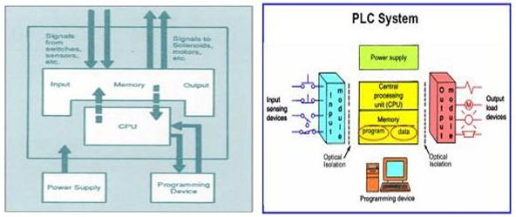

A basic PLC system consists of the following sections:

1. **Input/ Output Section**: The input section or input module consists of devices like sensors, switches, etc. The input from the sources is connected to the PLC through the input connector. The output section or output module can be a motor or a solenoid or a lamp or a heater, etc.
2. **CPU or Central Processing Unit**: It is the brain of the PLC. It can be a hexagonal or an octal microprocessor. It carries out all the processing related to the input signals in order to control the output signals based on the control program.
3. **Programming Device**: It is the platform where the program or the control logic is written. It can be a handheld device or a laptop or PC.
4. **Power Supply**: It generally works on a power supply of about 24 V, used to power input and output devices.
5. **Memory**: The memory is divided into two parts - the data memory and the program memory. The program information or the control logic is stored in the user memory or the program memory from where the CPU get the program instructions. The input and output signals and the timer and counter signals are stored in the input and output external image memory respectively.

### **Microprocessor**:

There are five important components in a microprocessor. They are Arithmetic and Logic Unit (ALU), Control Unit, Registers, Instruction Decoder and Data Bus but the first three are considered significant components.

There are three basic characteristics used to differentiate microprocessors: instruction set, bandwidth and clock speed. Instruction set - is related to programming of the microprocessor which consists of instructions that a microprocessor can execute. Bandwidth - indicates maximum number of bits processed in a single instruction. Clock speed - gives number of instructions a processor can execute per second. Usually clock speed is in MHz or GHz. Generally the characteristics of bandwidth and clock speed are looked together - the higher values of both these characteristics, the more powerful processor is.

The block diagram of a microprocessor with these basic components is shown below:

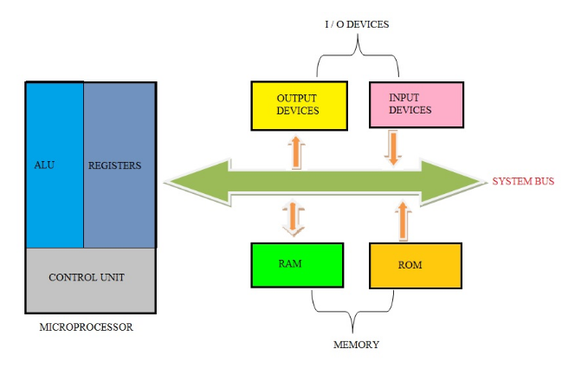

The internal structure of a microprocessor is shown below:

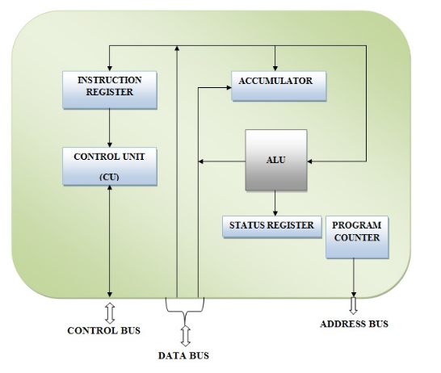

There are 2 types of architectures: Hardward and Von Neumann.

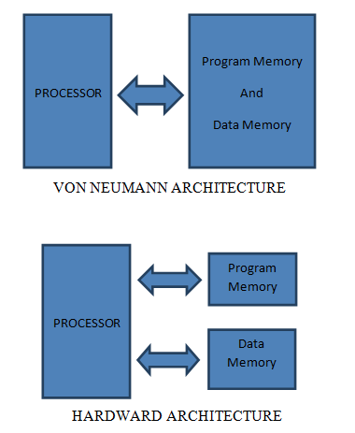

**Von Neumann Architecture:**

1. The computer has single storage system (memory) for storing data as well as program to be executed.
2. A single set of address/data buses between CPU and memory.
3. Processor needs 2 clock cycles to complete an instruction. Pipelining the instructions is not possible with this the first clock cycle the processor gets the instruction from memory and decodes it.
4. In the next clock cycle the required data is taken from memory. For each instruction this cycle repeats and hence needs 2 cycles to complete an instruction.

**Harvard Architecture:**

1. The computer has two separate memories for storing data and program.
2. Two sets of address/data buses between CPU and memory.
3. Processor can complete an instruction in 1 cycle if appropriate Pipelining strategies are implemented.
4. In the first stage of Pipeline the instruction to be executed can be taken from program. In the second stage of pipeline data is taken from the data memory using the decoded instruction or address.
5. Most of the modern computing architectures are based on Harvard architecture. But the number of stages in the Pipeline varies from system to system.

**A6. Describe the working of domestic applications :**

To begin with PLC is one of the possible solutions for domestic applications, it’s more expensive than the rest of typical microcontrollers, but for sure it’s more reliable, because basically it used in industrial field (but for domestic purposes it could be used as well). It used in full hose automation, or controlling separate parts or processes inside the building. Preferably application of PLC is automation of the routine processes on the specific area or inside the building. To do this, you have to use a necessary type of PLC for your project and a set of sensors which will give a response for your system. Also, you could use HMI for controlling all systems inside your building.

PLC could be used for temperature control inside the house, heating or cooling the water, or for automation of your daily routine processes like opening garage or windows, even for controlling of the solar panels and make them rotate according to the sun shadow. You could also include some alarm systems and features for emergency stop of all the processes. (Usually in most cases emergency stop is more a hardware part, but for example in Allen Bradley PLC 8xx series you could add extra rung with special function block, which will simulate a software emergency stop).

**Question 2:**

**A3. Explain the working principles of analogue and digital inputs sensors and outputs actuators.**

**A5. Describe the working of intelligent applications .**

**A7. Describe the working of Electrical and Mechanical PLC industrial applications.**

**C1. Evaluate the use of analogue to Digital Converter (ADC) and DAC in PLC systems.**

**C2. Evaluate the concept of integration of PLC systems and its relationship with SCADA systems.**

**Task1:**

1. Whenever the word ‘go’ is sent from the Realterm software to the plc, LED should switch on. If the word ‘no’ is sent LED should switch off.
2. The room temperature is to be read and sent back to the Realterm. Realterm should display the room temperature
3. Produce a documentation for the above tasks.

To begin with, in this task I’ve used PLC, PC connected to PLC and laptop with Realterm to send and receive data from PLC. On PC I’ve done a program to measure temperature in real time and upload it to PLC. As you could see on pictures below, first 6 rungs is related to reading data from my laptop. In my program “g” is used to switch ON LED and “o” is used to switch it OFF.

In this program, apart of Ledder programming we had to set on slots of the PLC. Set the parameters and make them enable and change from I to V.

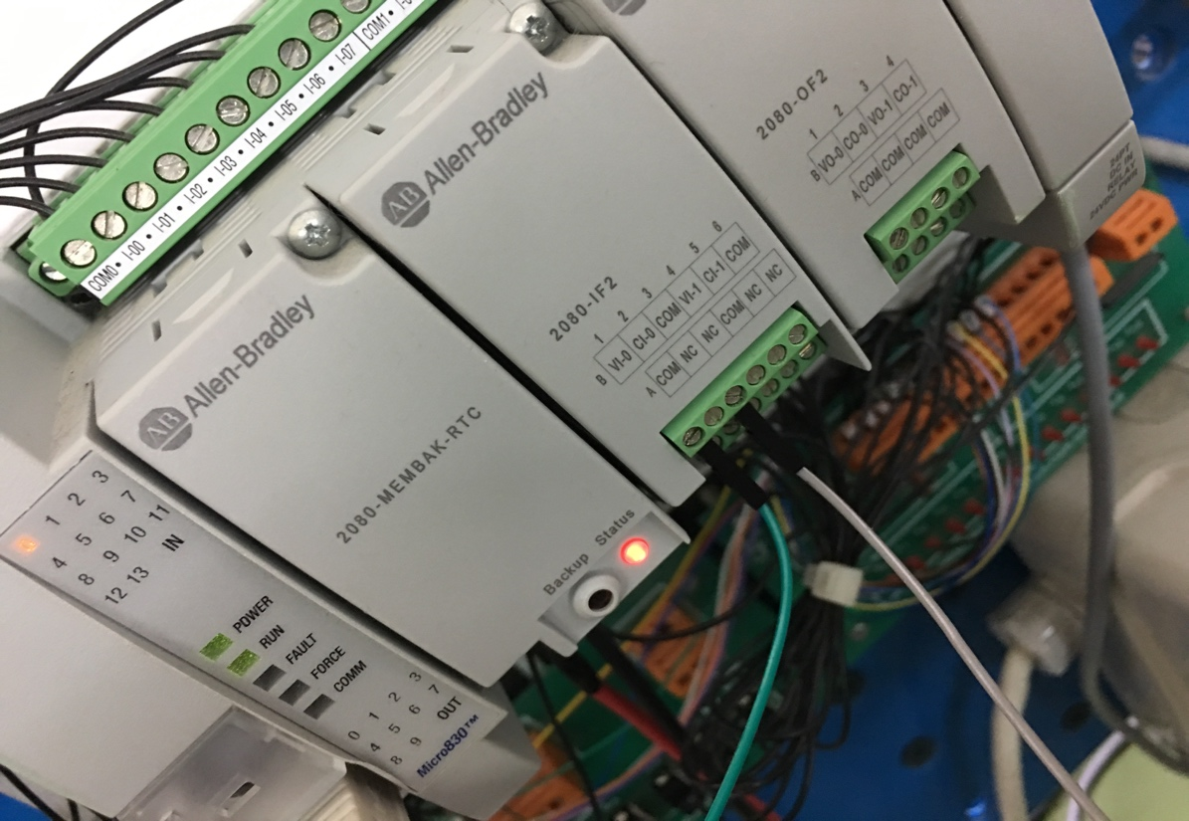

The principle of using Realterm is next, we insert a variable on the laptop, then press send data, it sends the ASCII code to PLC, when we press the switch which is responsible on this step, our PLC receive data and LED is ON ( if ASCII value is correct if not, LED is OFF), same procedure to switch OFF LED, but with another switch and variable.

Then I add another function to read data. We had use special functions to convert our data, because we can send raw data. In case of sending the data and receiving it we had used converters from analogue to digital.

**Task 2:**

1. Whenever the word ‘go1’ is sent to the plc the following piston mechanical movement is to executed for 1 time.

Piston 1 out – (delay)- Piston 2 Out – (delay)- Piston 1 In –(delay) - Piston 3 Out – (delay) -Piston 3 In – (delay)- Piston 2 in

1. Whenever the word ‘go2’ is sent to the plc the following piston mechanical movement is to executed for 1 time.

Piston 3 out – (delay)- Piston 2 Out – (delay)- Piston 2 In –(delay) - Piston 1 Out – (delay) -Piston 3 In – (delay)- Piston 1 in

1. Produce a documentation for the above tasks.

In this task we had to follow a sequence of switching ON and OFF the pistons. The sing is, that according to our hardware, one piston is working with one actuator (if it’s high piston is ON, if it’s low piston is OFF), and the rest two are working with 2 actuators each (to make it ON we have to set one actuator high, to make it OFF we have to release first actuator and set another one to high), that is why program is not similar for all pistons. First 6 rungs is realated to Realterm, like in the first task (we use it for communication between laptop and plc). The solution for this program was found with Timers, according to them I had created the sequence.

**Task 3:**

You are requested to share data communication and send processes between 2 allen Bradley PLC’s (5000) series. Name typical applications where such intelligent systems are requested.

In this task we were working with PLC Allen Bradley 5xxx series.

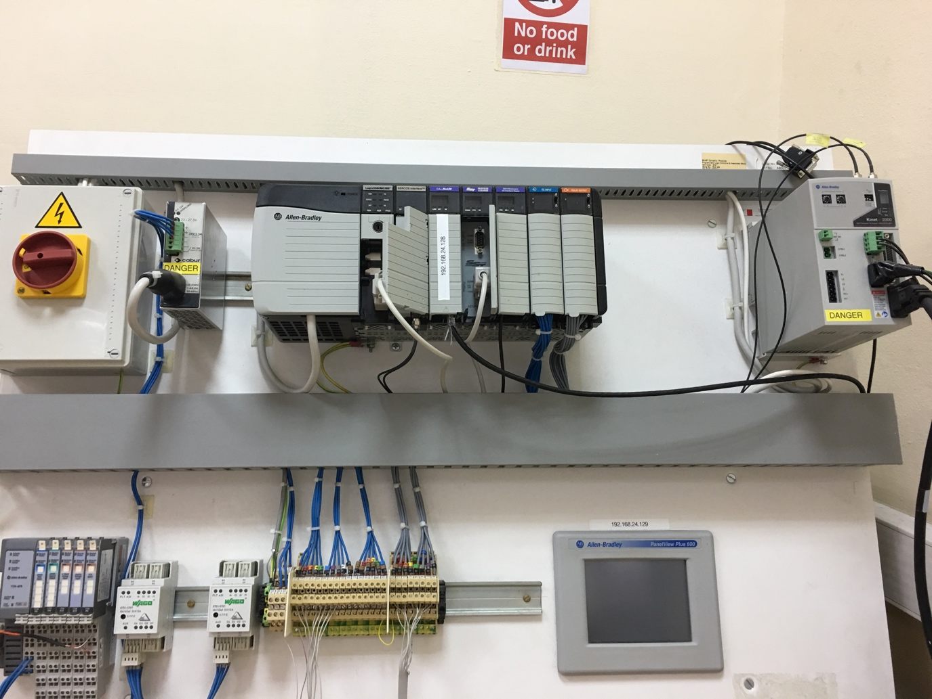

The idea was to connect 2 PLCs between each other and control actions of PLC A from PLC B and vice versa.

We had used a special procedure in which we had set necessary parameters for our PLCs, the difference in procedure was IP address, the rest is similar. In my program, when I press button 1 (PLC A) – the LED is ON (PLC B), when I press button 2 (PLC A) – the LED is OFF (PLC B), and vice versa (from B to A).

In the Ledder diagram there is a difference in 2 functions (2 MOV), in the PLC which is going to receive data, we have to change numbers of source (for example: if PLC A has 1 and 2 – we will need to write 2 and 1 in PLC B).

Power switch. Gives power to PLC.

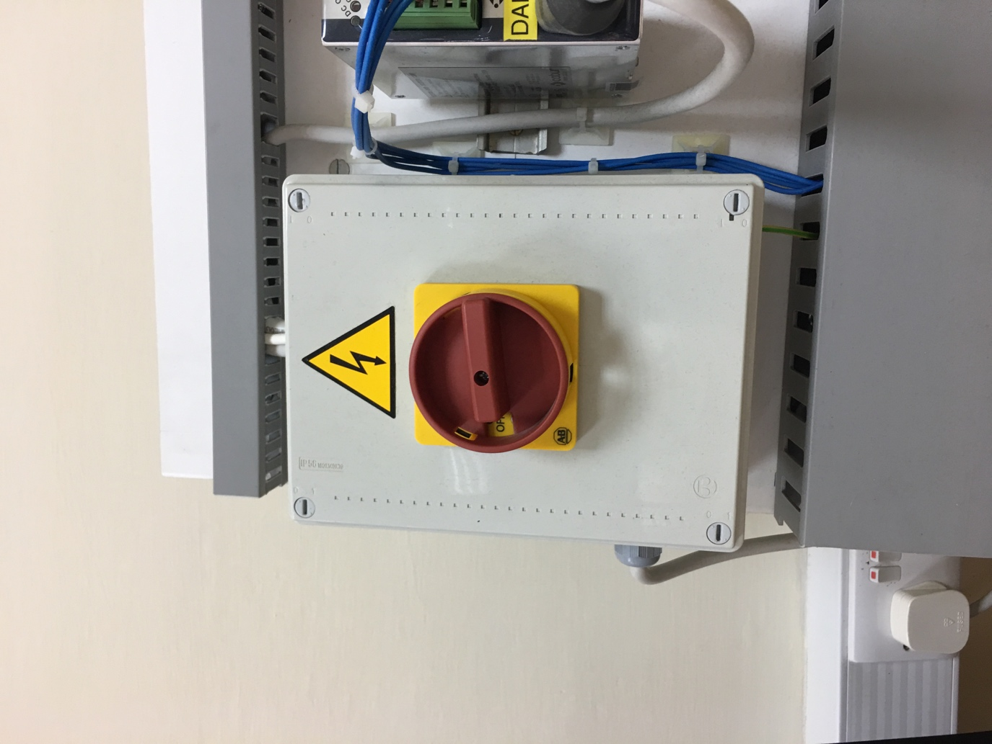

PLC 5xxx series and slots with Ethernet and DC input and output which we used in our program.

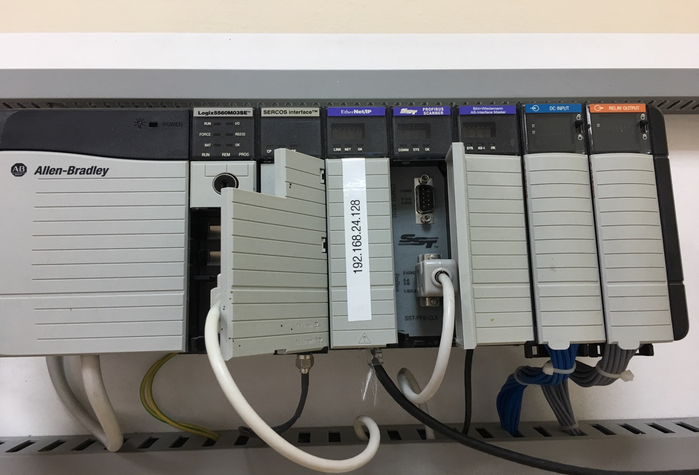

Here is photos of the program and variables which was necessary in our program. (Unfortunately “OpenNote” document hasn’t opened on my laptop, that is why I insert photos instead normal documentation).

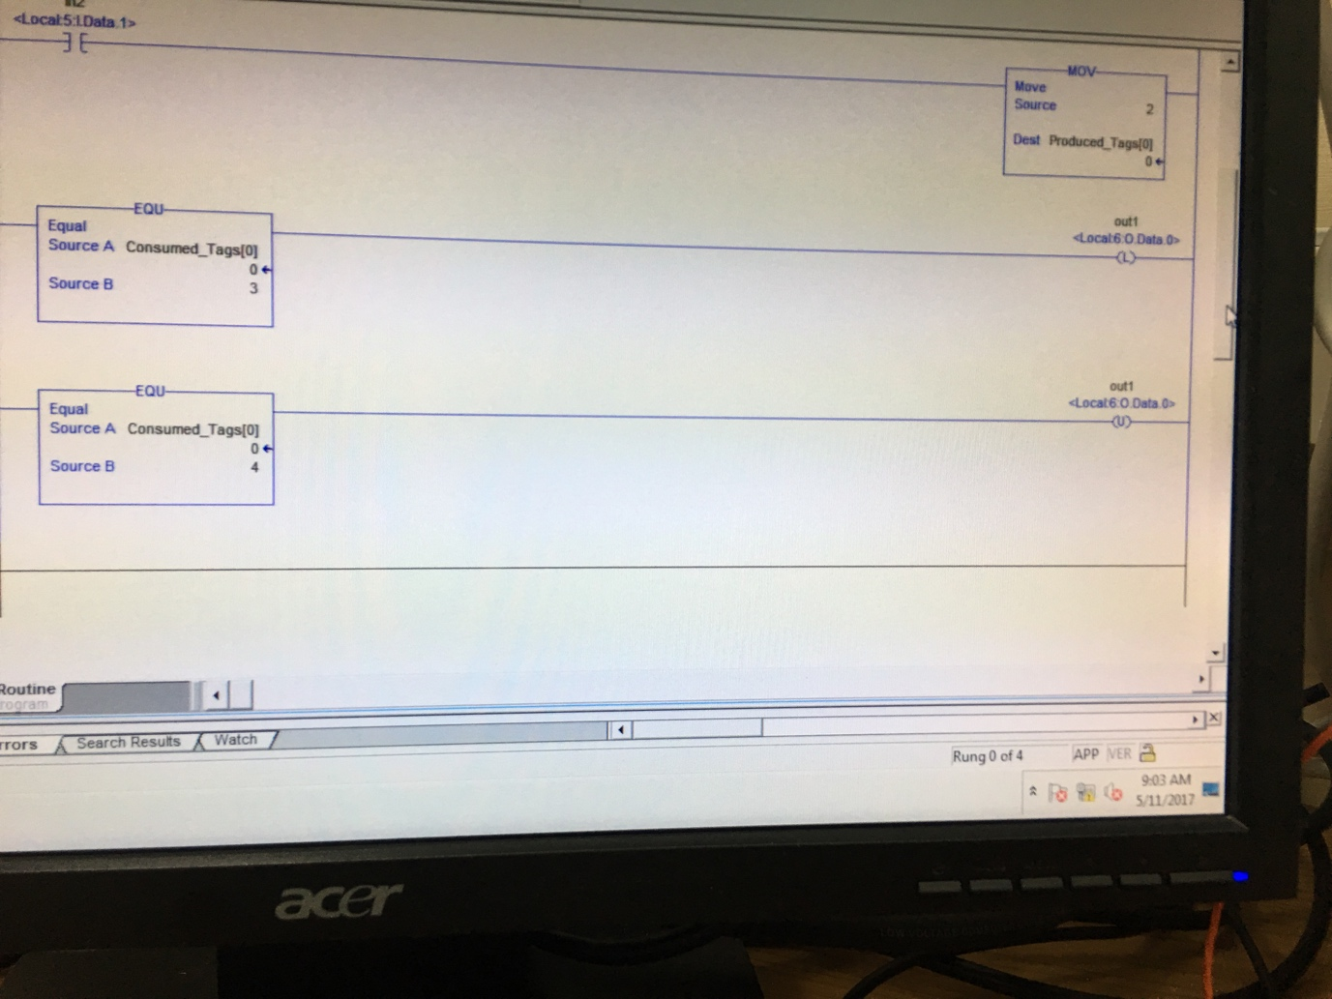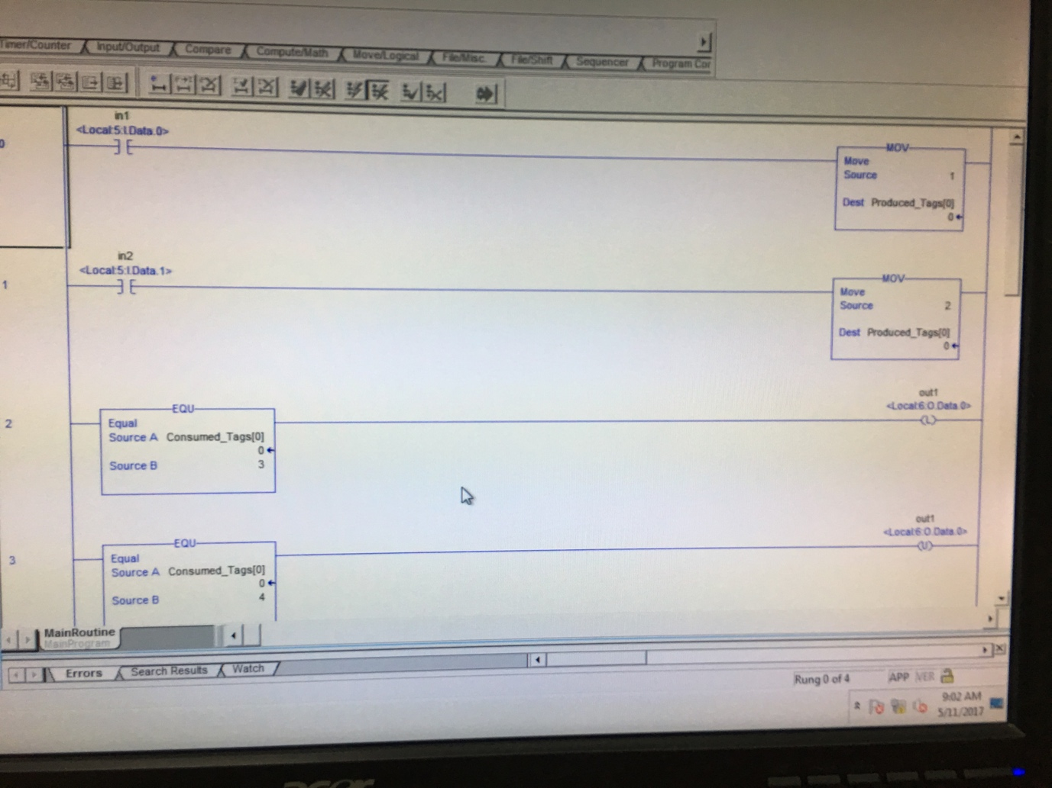

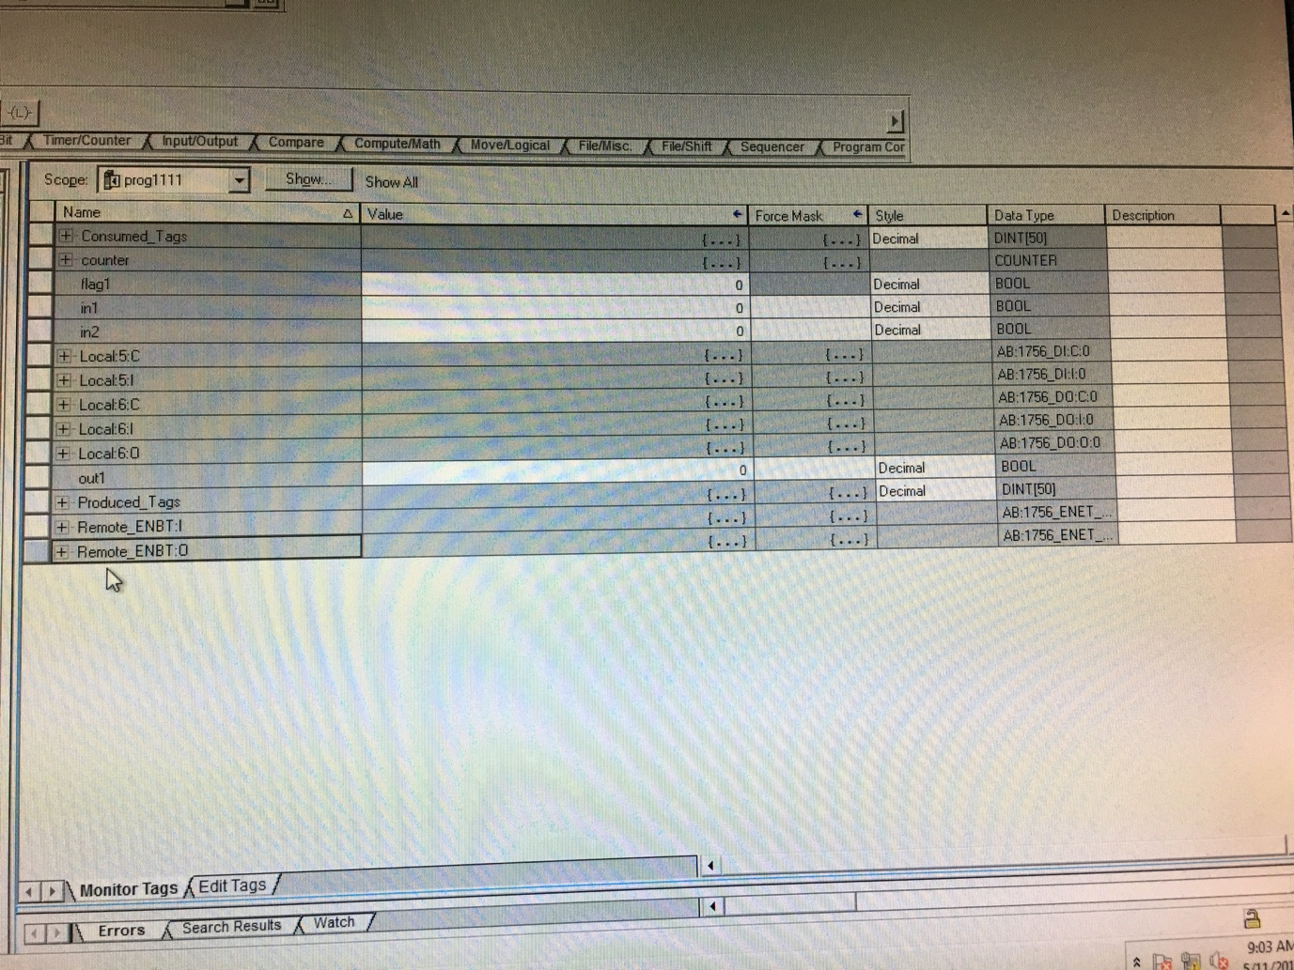

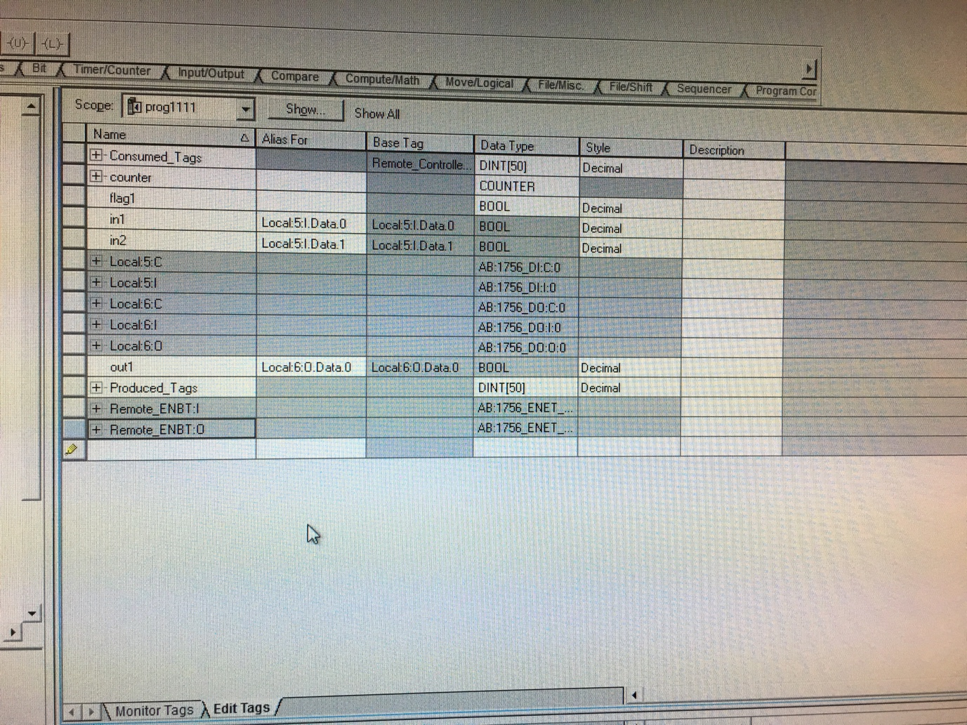

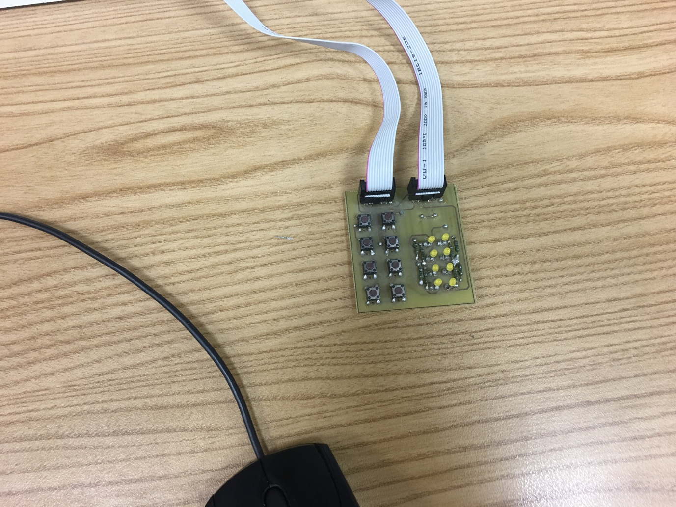

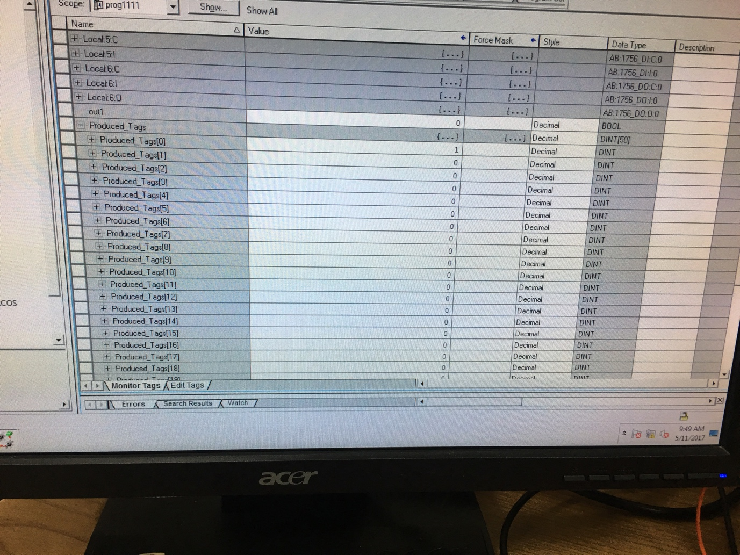

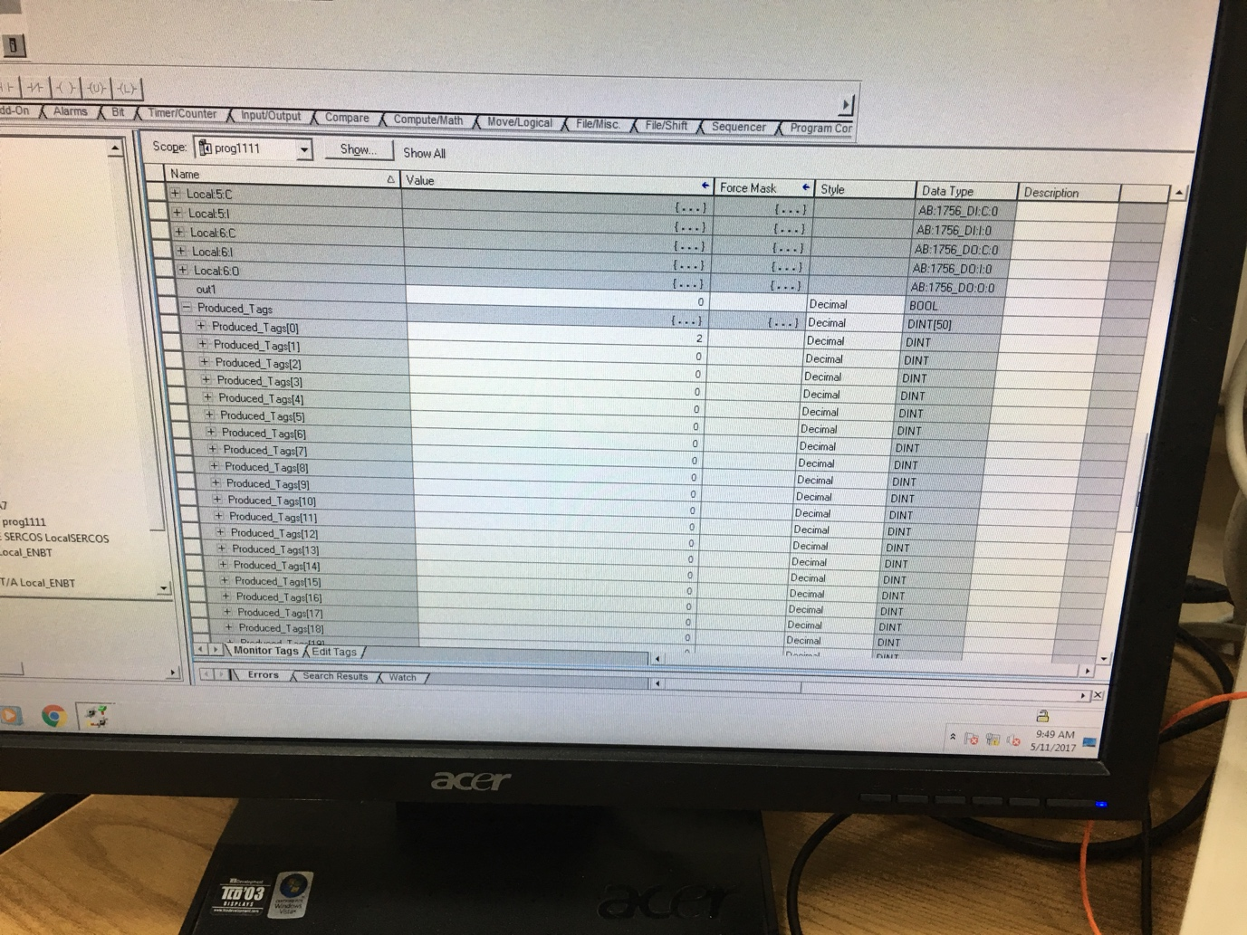

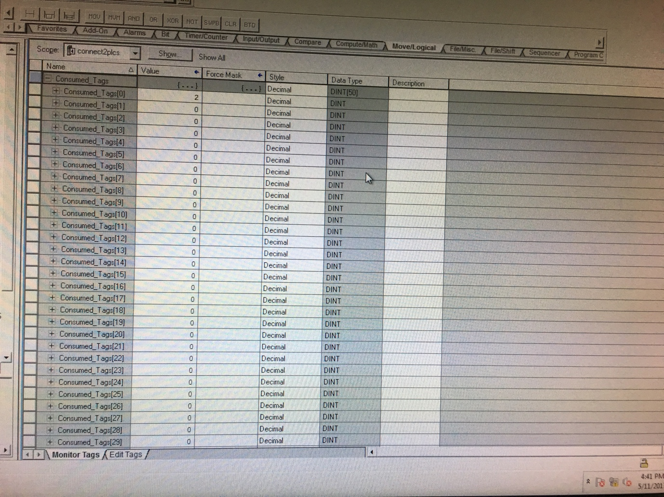

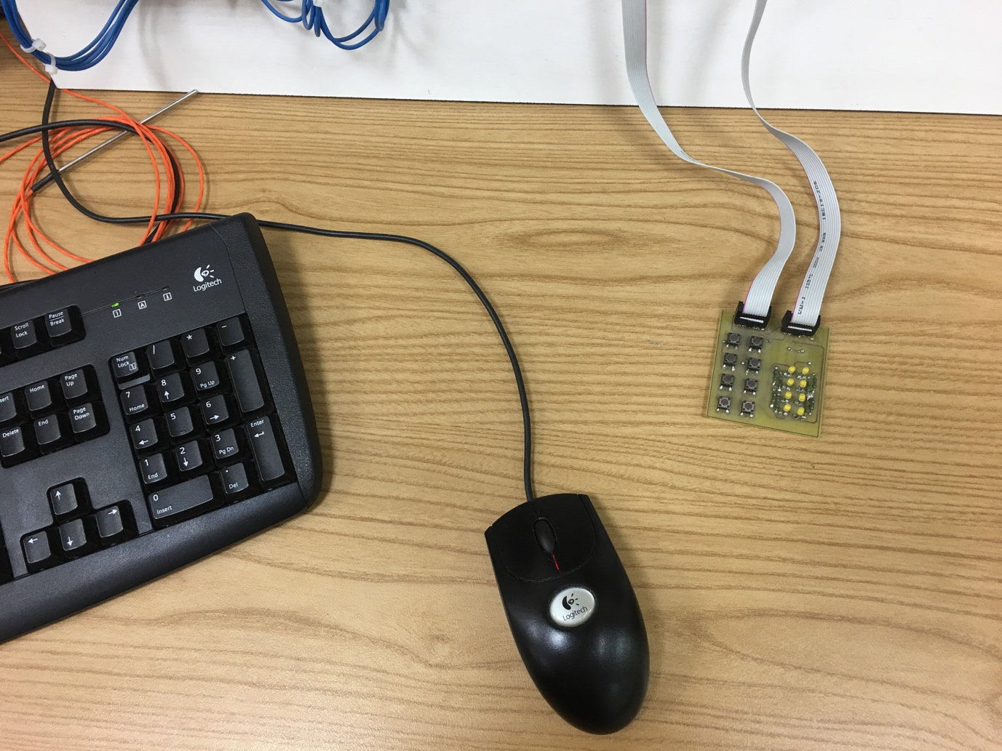

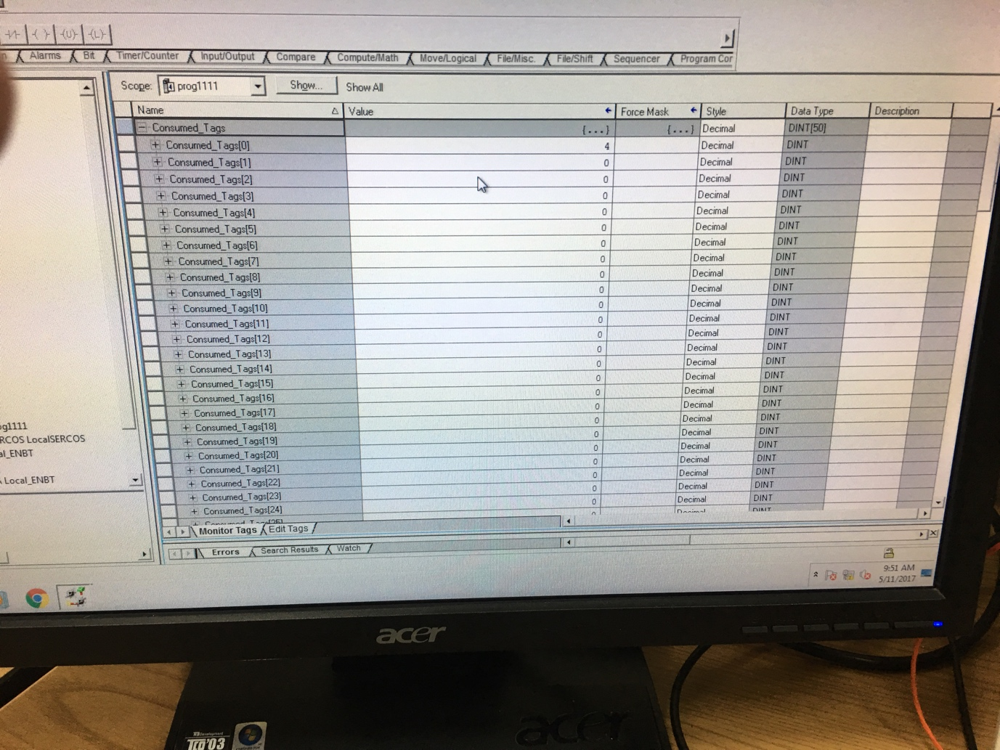

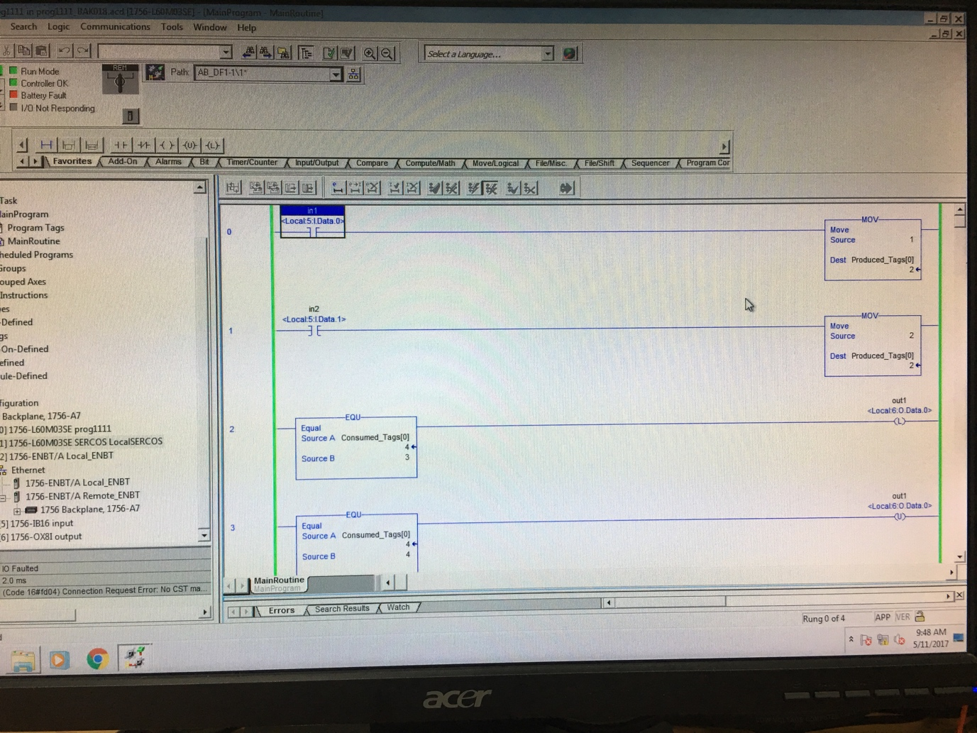

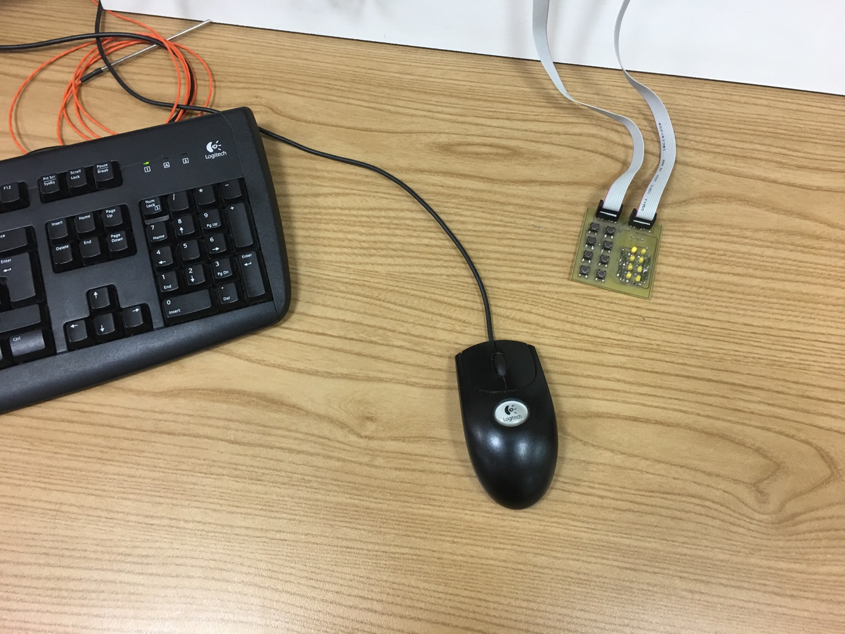

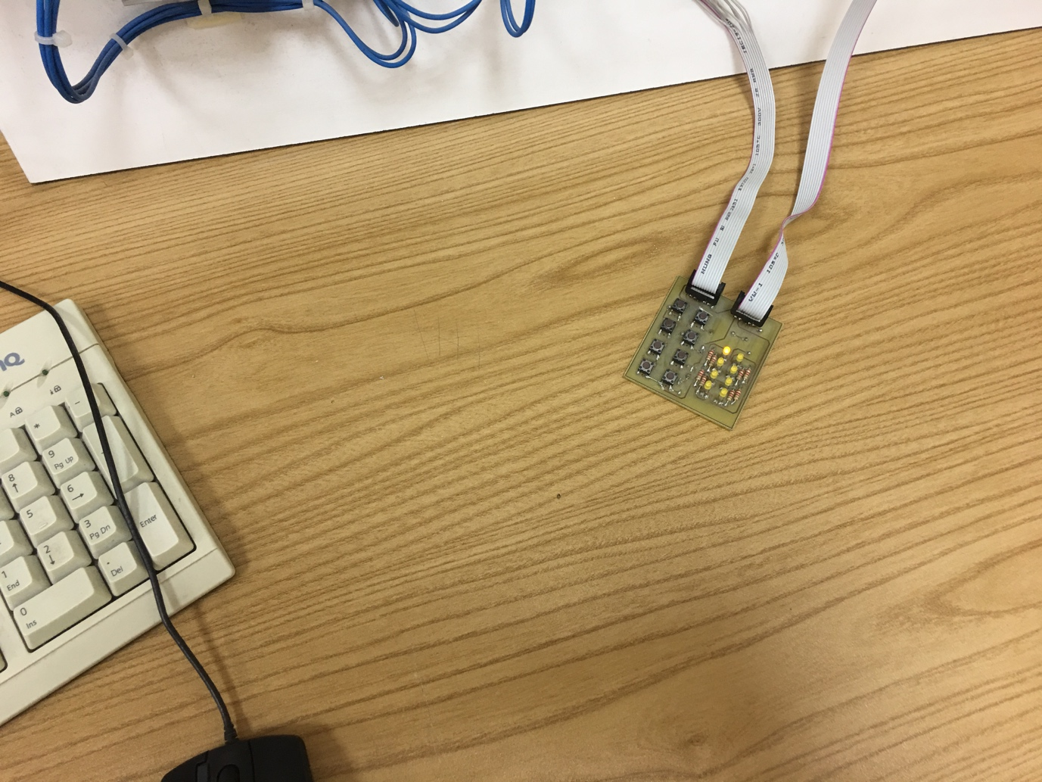

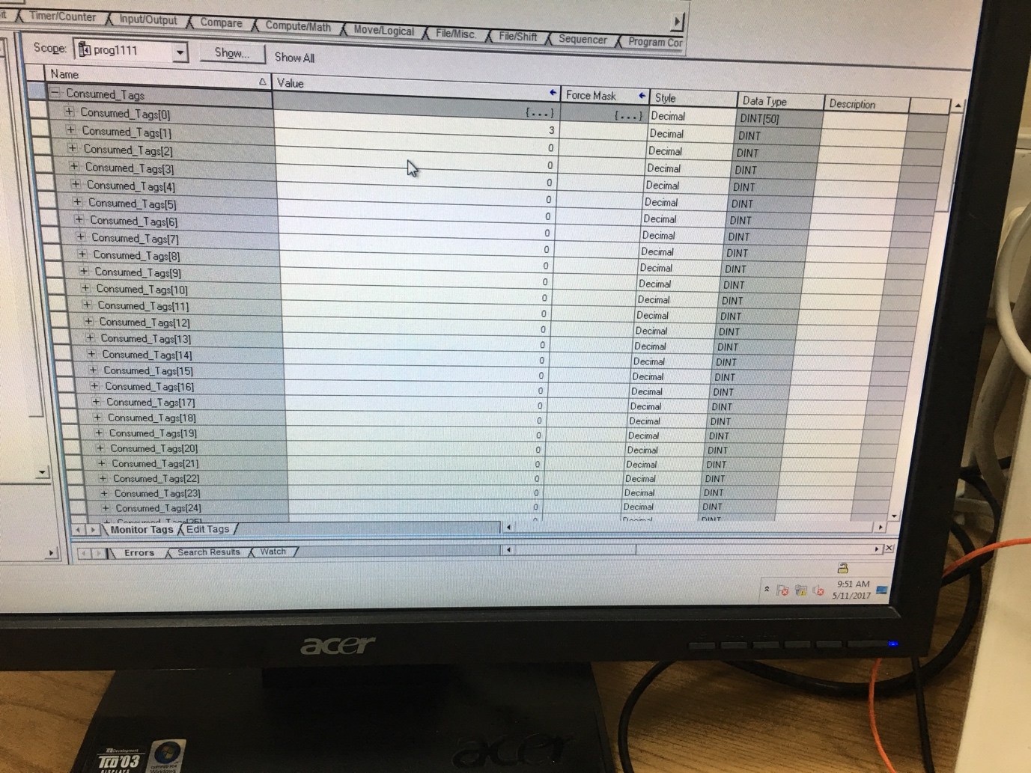

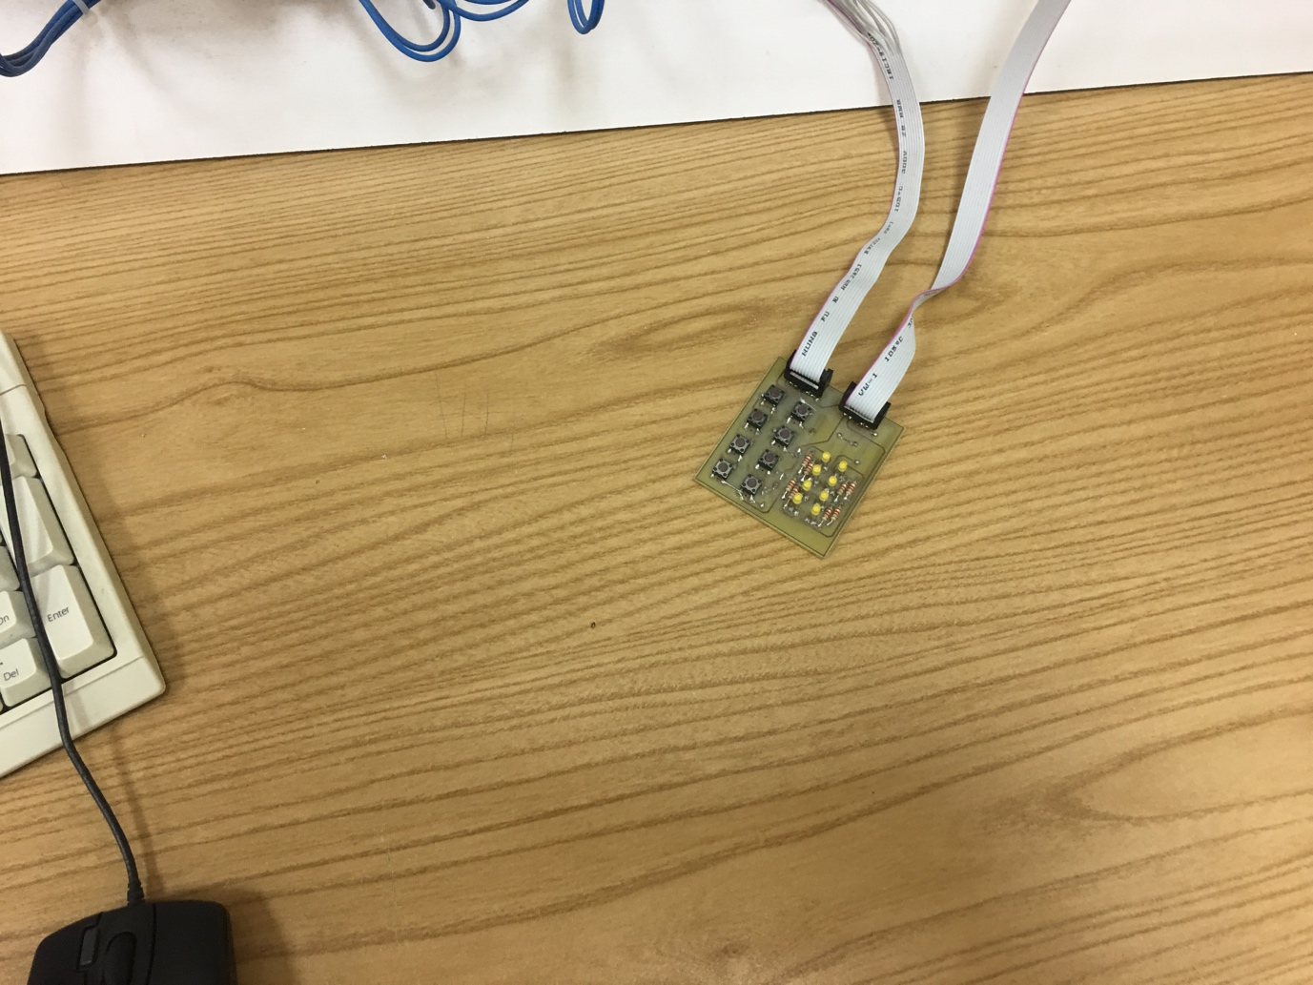

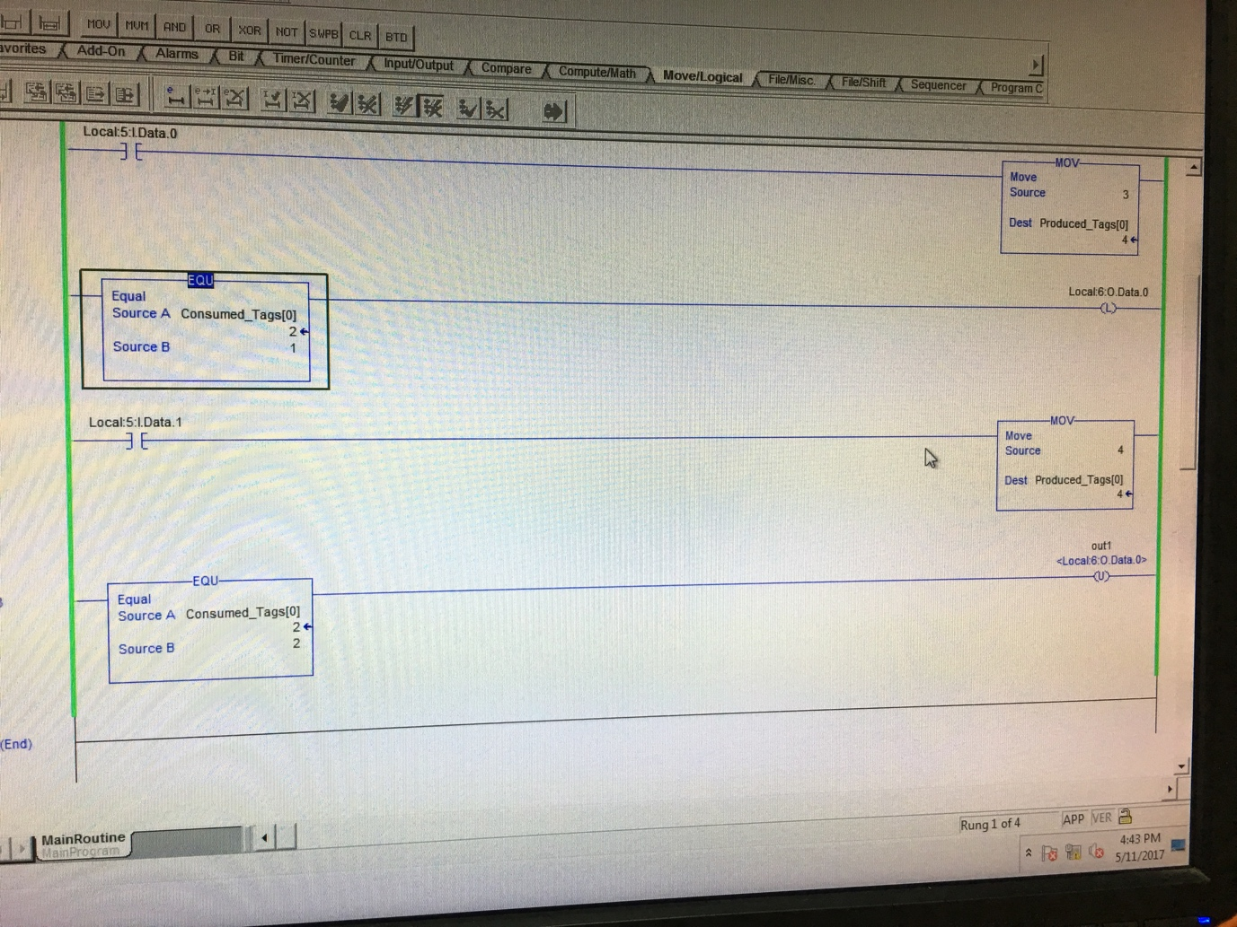

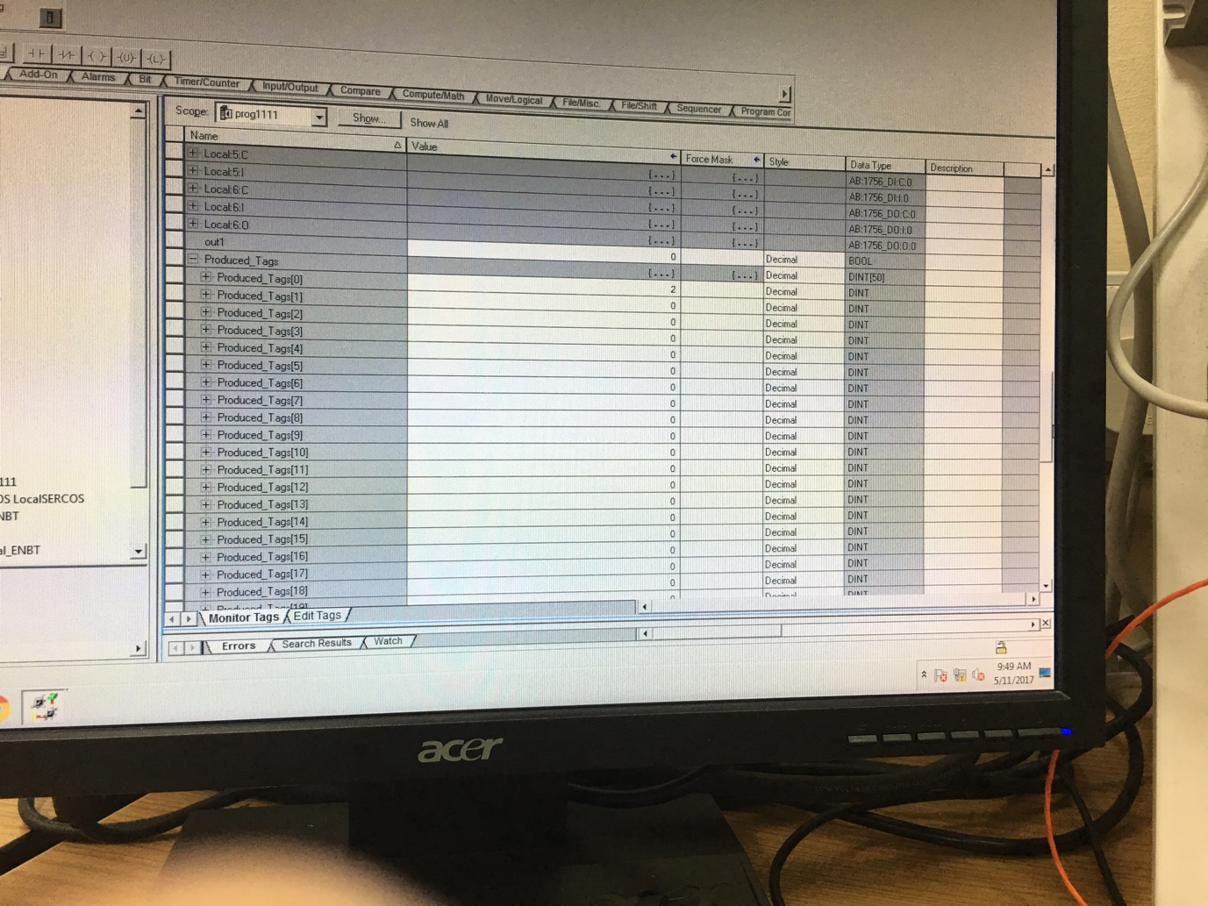

As you could see, there is a procedure of checking the process. As a prove you could see the LED and difference in Cunsumed tags and Produced tags.

**Summary of Question 2:**

To use analogue input we have to initialize a special slots in PLC as it was shown before, and set the correct parameters (for example change from current to voltage, to work with voltage in our program), similar with digital inputs (for sure in both cases wires and connections are very important). Set parameters for sensors and actuators depend on the hardware of the components which we are going to use (the example with pistons was described above).

If we use separate interface (in our case laptop) we have to use a special cable for PLC and 2 serial converter for laptop, than we could share data between this two. For sure, for correct use of Realterm we have to set correct parameters like frequency and how many bits we are going to send or receive, etc.

In the industry PLC is commonly used nowadays, because they are easy to program and they are very reliable. They used for automation and controlling processes in the area of use, inside the buildings, factories and for automation of routine processes (for pistons, temperatures control, conveir belts and etc).

We have to use ADC and DAC in our PLC systems because, we can’t work with raw analogue signal (like it was in task 1), we have to convert it to voltage and than according to it, do necessary actions, and same vice versa. Both functions are very important (for example: on the factory you have to control temperature of water in the sink, to read the temperature you will use ADC, to change the temperature in the sink, you will use data which you grab and than according to your data and parameters you will use DAC, to calibrate temperature in the sink. And there are a lot of applications where this converters could be used).

**PLC :**  
[1) It](http://1.it/) is a solid state [device.](http://device.it/) It controls the output of the process through the program given in Ladder diagrams.

2) I/p & O/p are represented in NO,NC and coil contacts.   
3.Each component involved are defined using Address.   
  
**SCADA:**  
[1) It](http://1.it/) is a software. Used to monitor, control and acquire data from field devices even from remote locations.

2) I/p & O/p are represented in images.

3) Each object is defined using name.

PLC is a Hardware to read the sensor (physical signal) , solve the algorithm and gives the controlled output., whereas SCADA is the software which can be interfaced to PLC, to read and present the information in graphical, animated form or make log.   
  
**For example:**  
Controlling the LEVEL is done by PLC and info graphics of the level with information about it (level, criticle levels, alarm  etc.) from last 3 years or more is done by SCADA.

**Question 3**:

**Task 4: Explain the benefits of the above exercises with PLC technology rather than using off the shelf microcontrollers.**

To begin with there are some good points about PLC:

• They are highly reliable, fast and flexible.

• They can handle severe conditions such as dust, humidity etc.

• They can communicate with other controllers.

• They are easy to program and troubleshoot.

• They include display units.

If we talk about tasks above, we could notice that it’s more logic tasks and PLC is exactly about logic. Ofcourse we could use microcontroller but, exactly in our case and in the most industrial and domestic scenarios it’s more about logic.

There are few benefits about PLCs:

Direct interoperability to other industrial devices such as relays, valves, actuators, transmitters, motor starters and SCADA, etc.

PLCs are made for rugged and tough environment. A microcontroller cannot withstand dust like there is in cement industry, for example. A microcontroller cannot work in offshore environment with such high levels of humidity, corrosion, vibrations, etc.

Most of the PLCs can be easily integrated with other industrial networks by adding just another communication module. This is not the case with microcontrollers.

Almost all PLCs are modular. You can add/remove I/Os and other modules easily with PLC.

Microcontrollers are too small to handle hundreds and thousands of I/Os.

So in the end I want to add that there are many other reasons(reliability, complexity, programming, etc) which suggest that PLCs are a better choice than a microcontroller in an industrial environment but here I've mentioned just the basic ones. And for sure all this parameters more or less is suitable for explanation why it’s better to use PLC than microcontroller for our tasks above. In conclusion : it’s better to use PLC, because it was the easiest way to solve the problem, it’s the main reason.